Chi Square Goodness of Fit, contingency tables

SAMPLE 1
You want to know a six-sided die is fair or unfair.
- H₀: p1 = p2 = p3 = p4 = p5 = p6 = 1/6 The die is fair, each side has an equal probability of coming up
- H_{a} : At least one p is not equal to 1/6 The die is not fair
Now, test 120 rolls of the die and enter the data into Excel (120 tries = expected number of 20 per side):
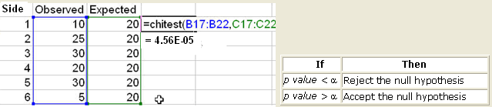
Conclusion: In the above results the p value = 0.0000456 which is lower than our alpha value of 0.05, so, we reject the null hypothesis that the die is fair
The reason why the die is not fair, is because for side 6, the number of times observed is very low (5 times).

SAMPLE 2

What is the probability that the observed value from 2 machines could under the hypothesis that both machines have same quality?
- H₀: Machine A quality = Machine B quality
- H_{a} : Machine A quality <> Machine B quality
OBSERVED |  |  |  |  | EXPECTED
 | Mach A | Mach B | Total |  |  | Mach A | Mach B | Total
Defective | 10 | 25 | 35 |  | Defective | 14 | 21 | 35
Good | 30 | 35 | 65 |  | Good | 26 | 39 | 65
Total | 40 | 60 | 100 |  | Total | 40 | 60 | 100

To generate expected values: Cell Value = (Row Total)*(Column Total)/Grand Total.

For Machine A / Defective = 35 * 40 / 100 = 14

Option 1 X² = SUM ( Observed – Expected ) ² / Expected

1.14 + 0.76 + 0.62 + 0.41 = 2.93 DF = (2-1)(2-1) = 1

The p-value is 2.93, between 0.05 and 0.10
- X² _{0.05} = 3.84 Excel CHIINV( 0.05, 1)
- X² _{0.10} = 2.71 Excel CHIINV ( 0.10, 1)

At alpha 0.05 X² _{0.05} = 3.84 > X² 2.93
There is insufficient evidence to say with 95% confidence that the quality from the machines is different

At alpha 0.10 X² _{0.05} = 2.71 < X² 2.93
There is sufficient evidence to say with 90% confidence that the quality from the machines is different

Option 2 CHITEST(observed, expected)

CHITEST:
- Gives percentage of confidence that both machines are similar
- If CHITEST is almost zero then we conclude: MACHINES HAVE DIFFERENCES

=CHITEST(B5:C6,G5:H6) = 0.0869 => 8.7% (BETWEEN 5% AND 10%)

Here p-value is less than 0.087 (level of significance).
Therefore we will reject H₀ at 8.7% of level of significance. Ho Machine A = Machine B

The probability that both machines are operating at the same quality is 8.7% (CHITEST value)
The probability that both machines are operating with different quality is 91.3%

There is a confident in 91.3% that both machines have different quality

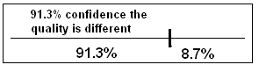

SAMPLE 3

OBSERVED |  | HOSPITAL |  |  |  |  |  | EXPECTED |  | HOSPITAL
Result | A | B | C | D | E | Total |  | Result | A | B | C | D | E | Total
No change | 15 | 6 | 8 | 20 | 44 | 93 |  | No change | 13 | 8.5 | 20 | 32 | 20 | 92.9
Low improve | 20 | 11 | 39 | 61 | 30 | 161 |  | Low improve | 22 | 15 | 35 | 56 | 34 | 161
High improve | 18 | 19 | 38 | 55 | 9 | 139 |  | High improve | 19 | 13 | 30 | 48 | 29 | 139
Total | 53 | 36 | 85 | 136 | 83 | 393 |  | Total | 53 | 36 | 85 | 136 | 83 | 393

To generate expected values: Cell Value = (Row Total)*(Column Total)/Grand Total.

For hospital B / Low improve = 161 * 36 / 393 = 14.7 = 15

Option 1 X² = SUM ( Observed – Expected ) ² / Expected

X² = 66.22

DF = (5-1)(3-1) = 8 X² (0.01 , 8) = 20.09 X² calc 66.22 > X² critical 20.09
Therefore, we reject the null hypothesis of hospital equality of results. With alpha 0.01

Option 2 CHITEST(observed, expected)

=CHITEST(B5:C6,G5:H6) = 2.51E-11 (almost zero) this implies HOSPITAL DIFFERS

IMPORTANT:
RULE OF THUMB: If CHITEST is almost zero, then we conclude THERE IS DIFFERENCE

SAMPLE 4
Men vs Women - Chi Square test Example
Imagine asking men and women if they agree, disagree or are neutral about a given topic. How will we know if they have the same or differing opinions? We can develop a null hypothesis (H₀) that men and women have independent views and an alternate hypothesis (H_{a}) that their views are related:
- H₀ men <> women
- H_{a} men =women
From a survey, men seem to agree more than the women do, but is it statistically different?
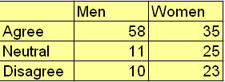
Select the data with the mouse and click on the QI Macros Menu to select the one sample Chi Square test:
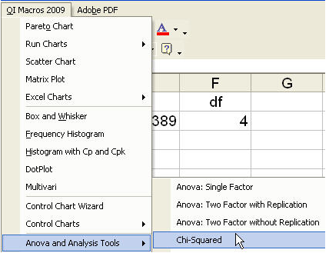
The Chi Square test macro will calculate the values and interpret the results for you:
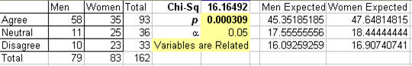
Note that we don't need the same number of responses from each group to get a result.
Interpreting the Chi Square results
If | Then
p value < α | Reject the null hypothesis | Variables are Related
p value > α | Accept the null hypothesis | Variables are Independent
In the above results the p value is 0.00031.
If the p value is less than the significance (e.g., α=0.05), we can reject the null hypothesis that men and women have independent views on the subject.

